Guidelines for full paper submission in ICEM19 (deadline 15th May 2020)
Dear ICEM19 participant
Thank you for submitting your paper to our conference.
Please follow the guidelines below to submit your manuscript for the proceedings.
1. First register on Sciforum.net with your email address, if you do not have an account yet.
2. Then click the “NEW SUBMISSION” green tab at the top right of the screen.
3. From the drop-down menu select from the list of conferences ICEM19 (currently at the bottom of the list). Click “Continue”
4. Select the unique session “ICEM 2020”
5. Fill in the required information about Poster/Oral presentation. (This is typical, and it is just a requirement of the website. It will not interfere with the preference that you already stated when submitting the abstract)

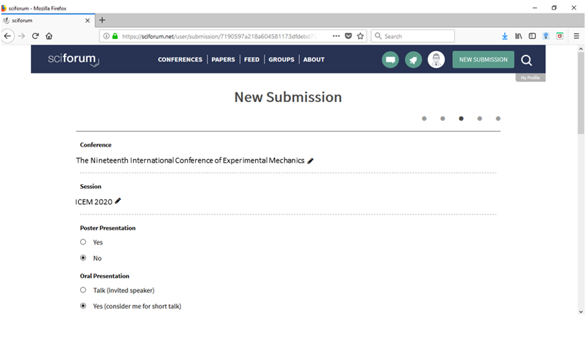
6. Fill in the title of your paper below with the abstract number you were given by the conference organizers as the first 3 digits (e.g. “225 Characterization of creep rupture in composites by nondestructive techniques”, the abstract and the keywords in the corresponding text boxes).
Here write the title of your paper and DO NOT FORGET to mention the abstract number at the front of the title in this box. E.g. “225 Characterization of creep rupture in composites by nondestructive techniques”
7. Now you are ready to submit your FULL MANUSCRIPT OF 8 PAGES. Attach the PDF and the original file (e.g. word) of your full manuscript in the boxes “Abstract (attachment) PDF” and “Abstract original files”. (It does not matter that mentions “abstract”, this is due to the design of the website. You upload FULL MANUSCRIPT here)
Click the check box “Open access” to authorize open-access publication of your paper.
Click here to upload FULL MANUSCRIPT of 8 pages in PDF
Click here to upload FULL MANUSCRIPT of 8 pages in word
Click here
8. Then you can add authors and affiliations by clicking “Continue to add authors”
9. Finally, you can “Preview submission” and then “Send to editors”
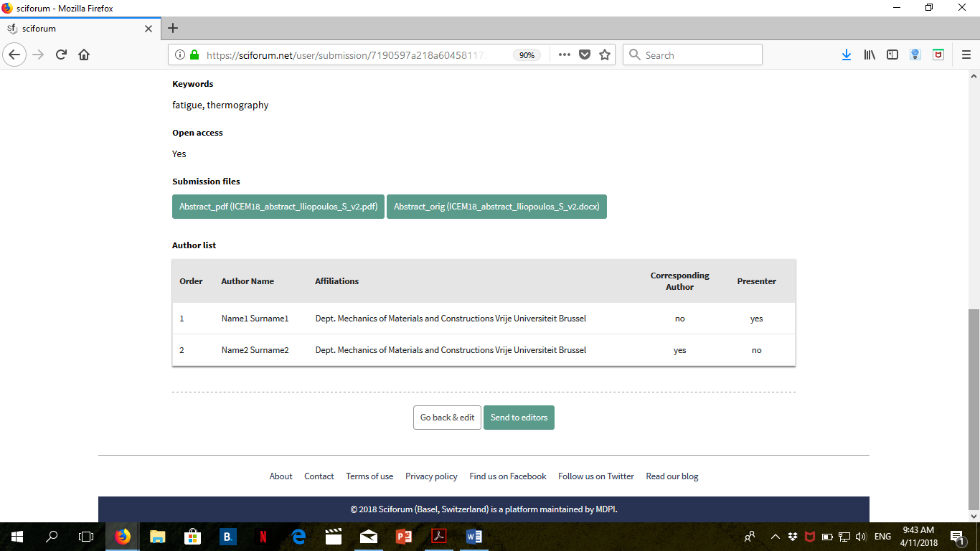
Click to finally submit your paper
You will see the following confirmation screen and receive an email by “info@sciforum.net with all the data of your submission. Please check your junk mail folder.
Your full paper for ICEM19 is submitted and the editors will handle it for review.

Thank you very much!

The ICEM19 organizing team

